Task 1 to 7:

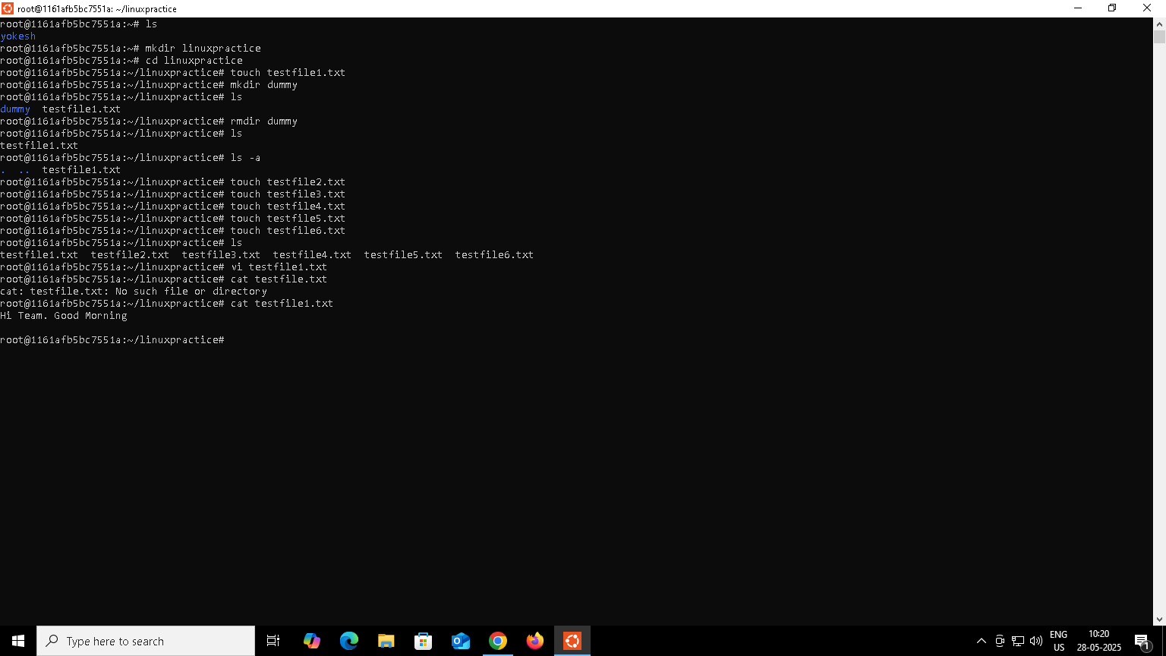

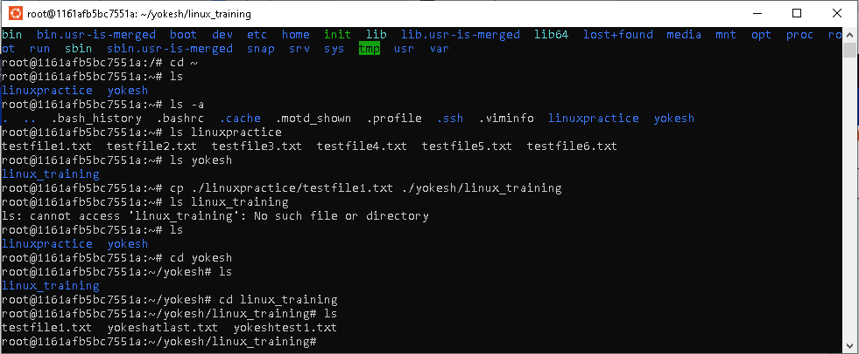

Task 7 to 9:

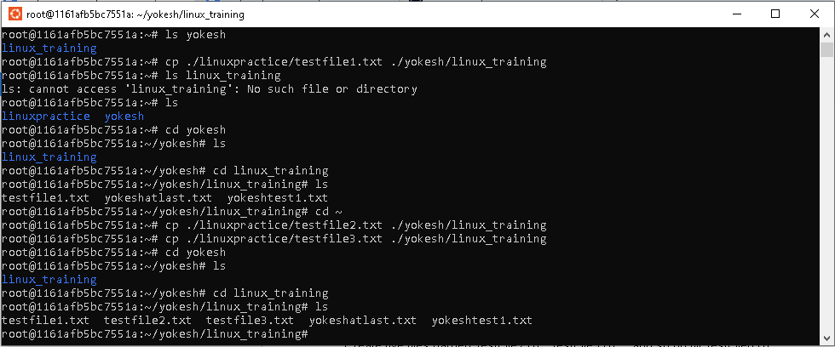

Task 10:

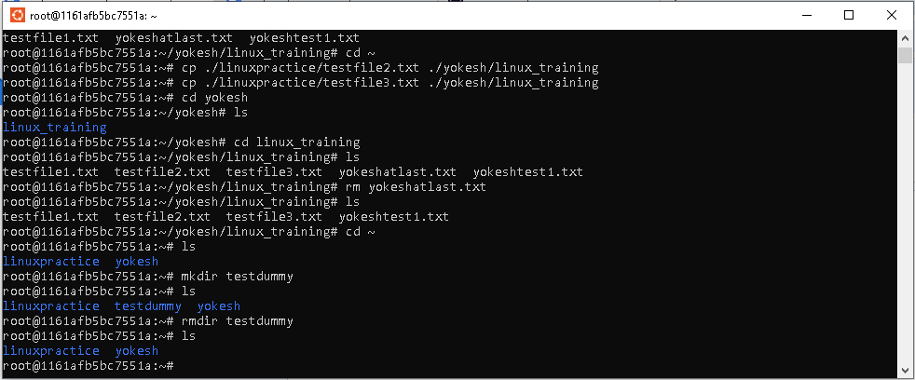

Task 11:

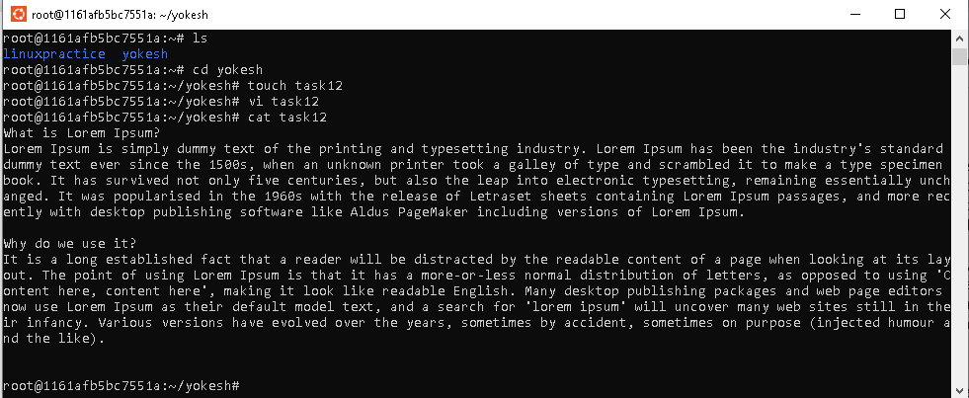

Task 12:

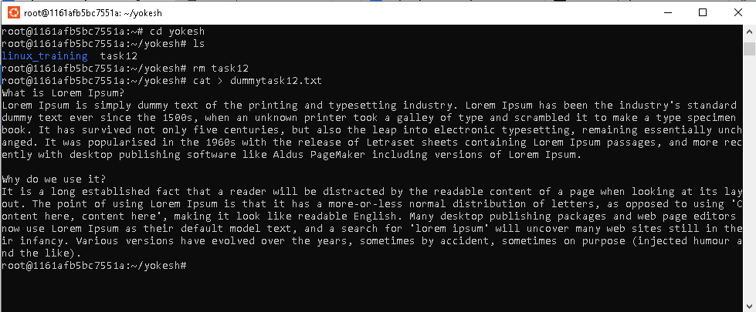

Task 13:

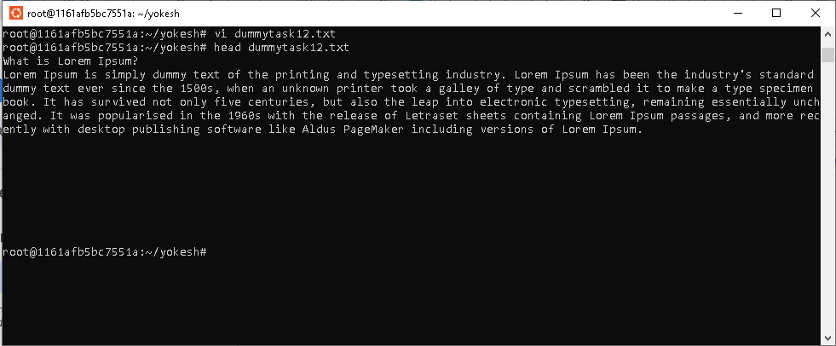

Task 14:

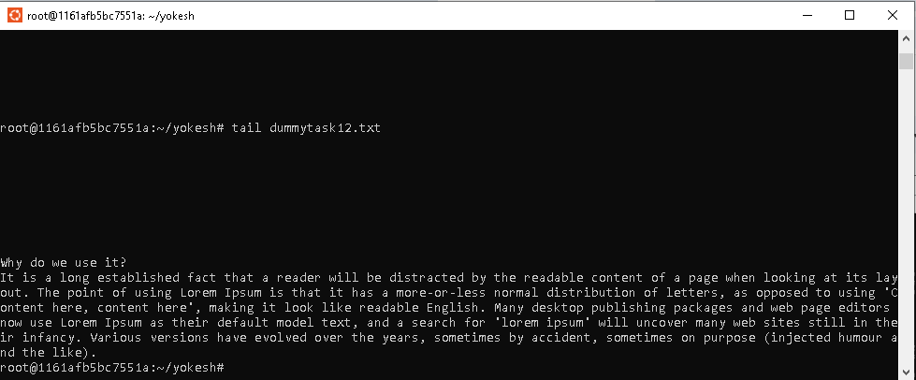

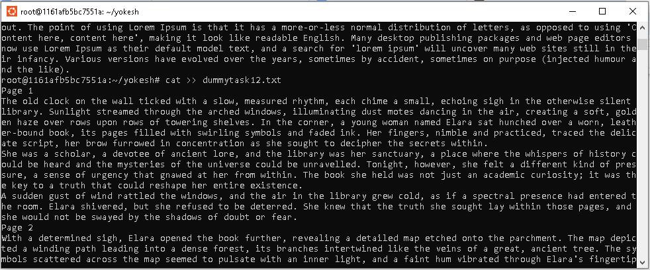

Less command

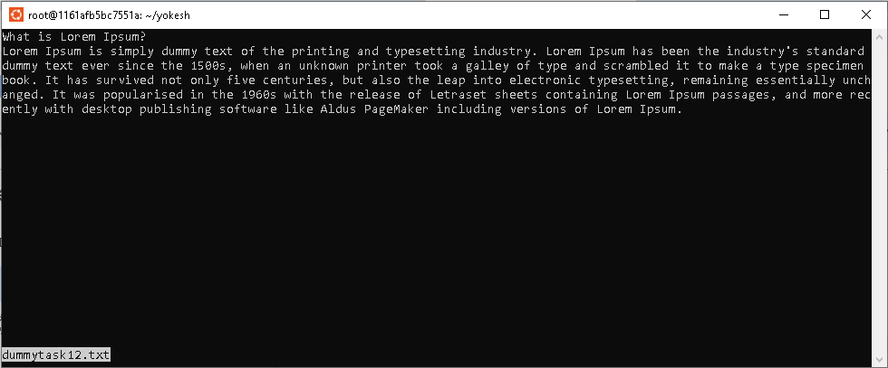

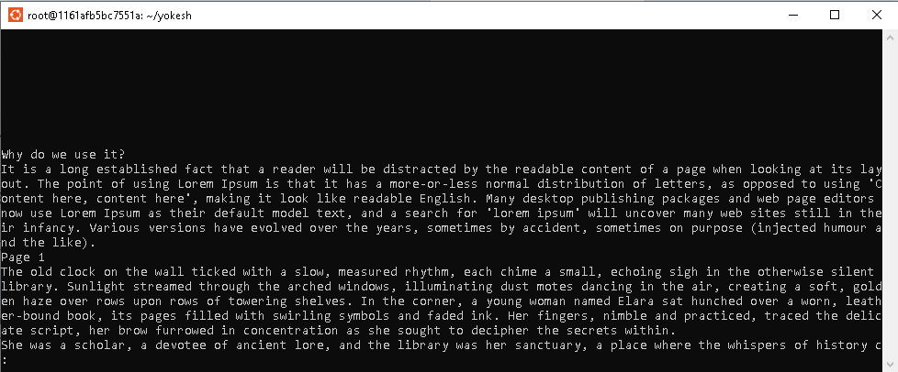

Spac bar to turn the pages

B to go back in the pages

Q to quit the less command

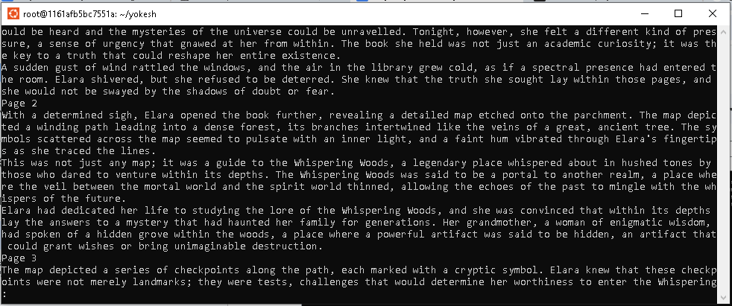

More command :

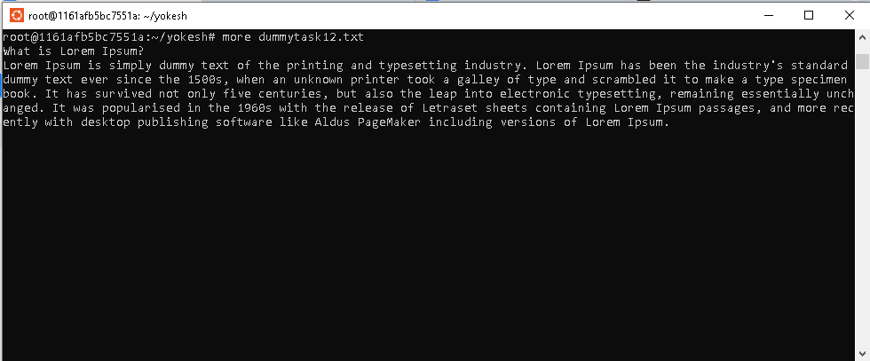

Difference between less and more command :

More can basic view and no backward scroll

Less can better control and scroll both ways

Echo -e:

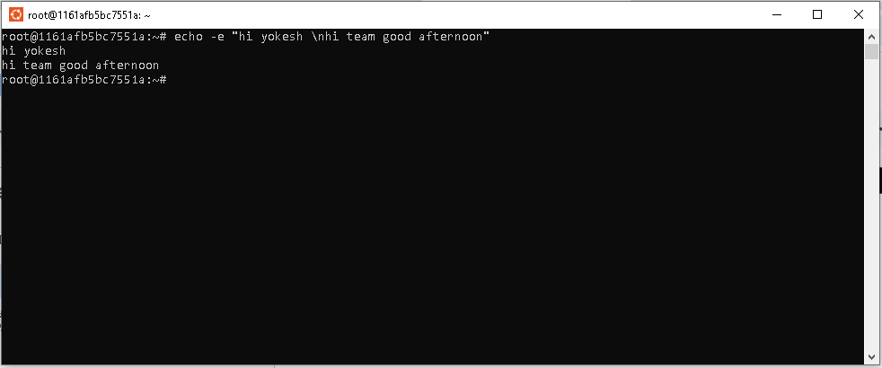

Ls -l:

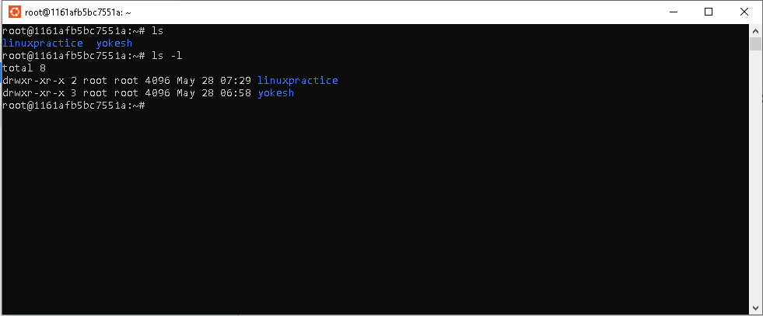

Touch, cat and echo:

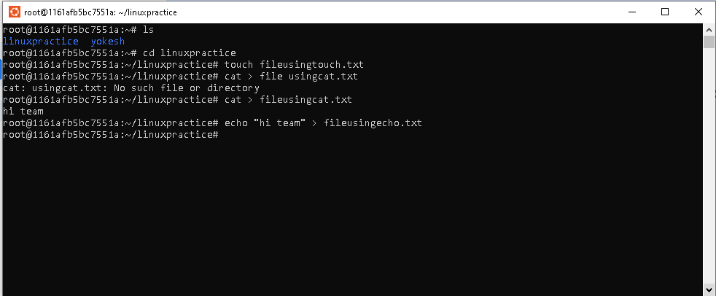

Difference between :

Touch,cat and echo

# **The touch command**

The touch command is used to create empty files or update the timestamp of an existing file. To create an empty file using the touch command, simply type touch filename at the command prompt, where "filename" is the name you want to give to the new file. For example, to create a new file called "myfile.txt,"

# **The echo command**

The echo command is primarily used to display messages on the terminal. However, it can also be used to create files by redirecting its output to a file. To create a file using the echo command, type echo "content" > filename, where "content" is the text you want to put in the file, and "filename" is the name you want to give to the file. For example, to create a file called "mytext.txt" containing the text "Hello World!", t

# **The cat command**

The cat command is used to concatenate files and display their contents on the terminal. However, it can also be used to create files by redirecting its output to a file. To create a file using the cat command, type cat > filename, then type the content of the file and press Ctrl+D to save and exit. For example, to create a file called "newfile.txt" containing the text "This is a new file," type:

Calendar display:

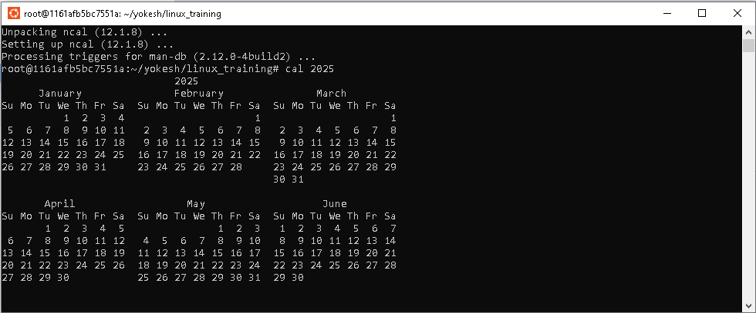

Going back one directory:

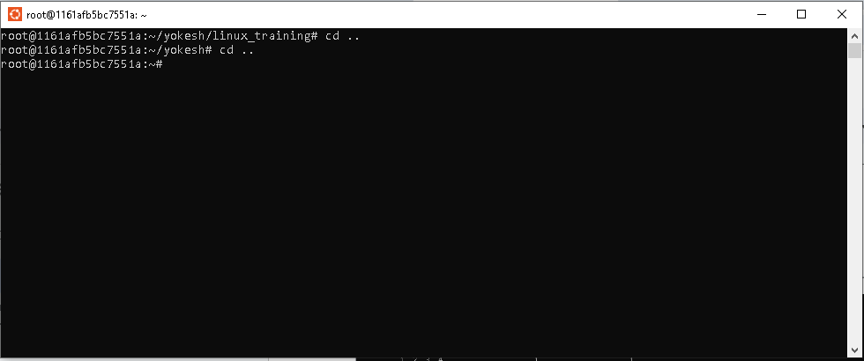

Whoami

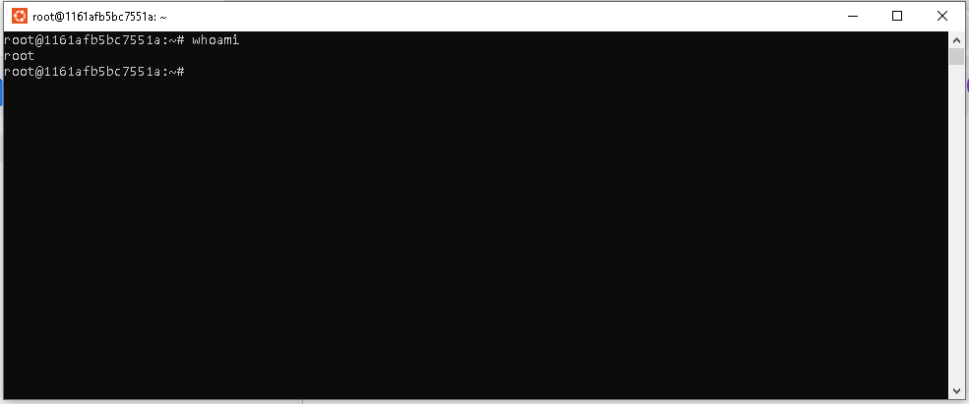

Task users, who, w:

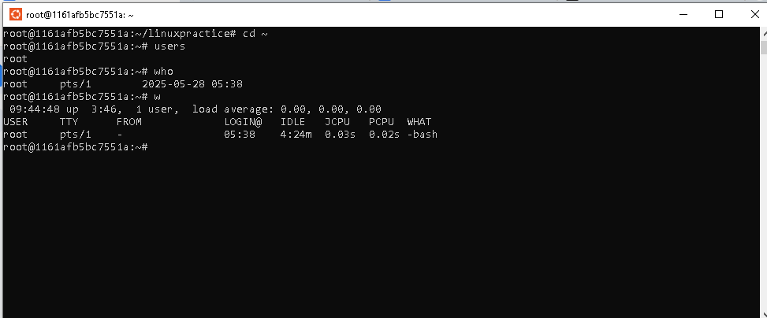

Task df -h:

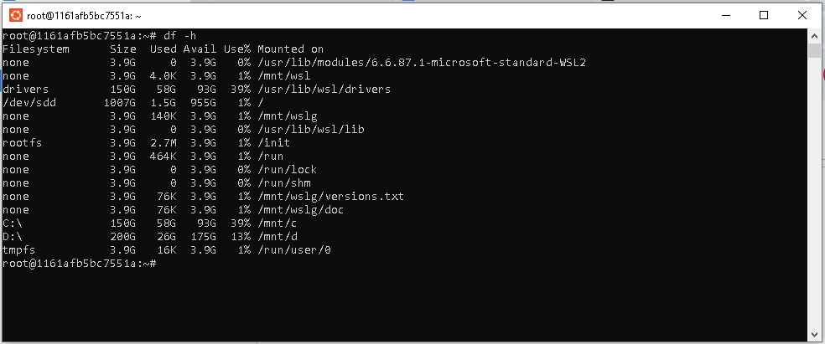

Task *.txt

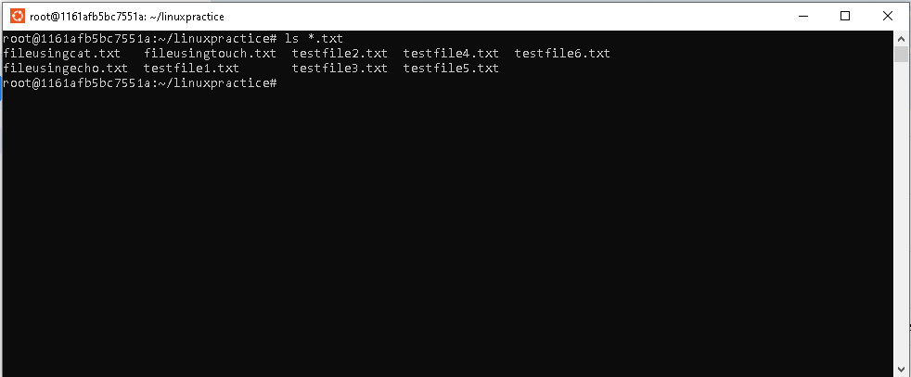

Task ls -a:;

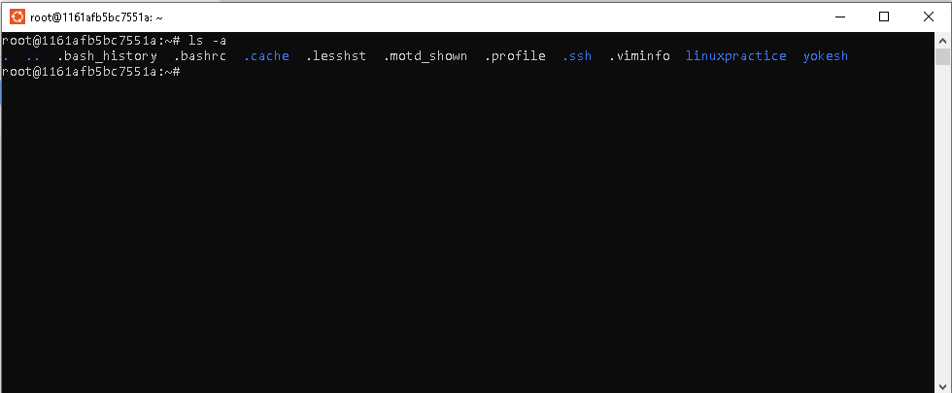

Task 27:

What is the difference between . and .. in linux

. refers to the current directory

.. refers to the parent directory

Task vi editor:

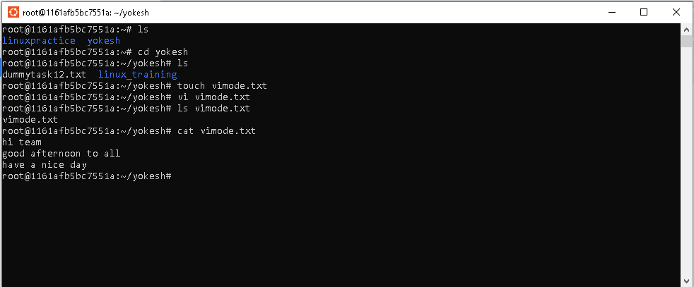

Task WC:

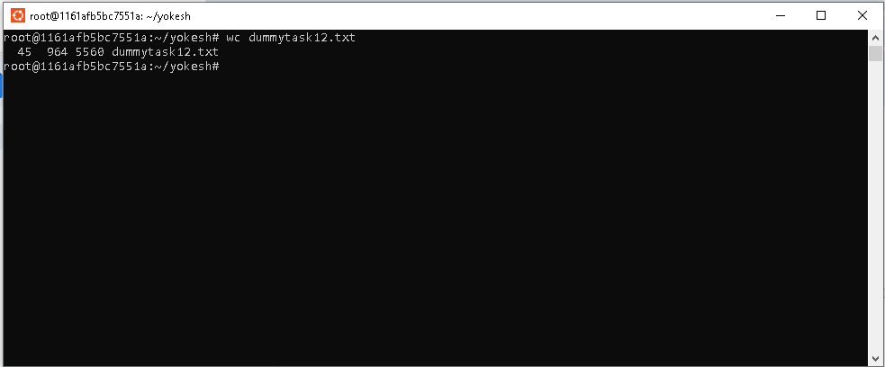

Task cat -b:

It shows the file content with line numbers

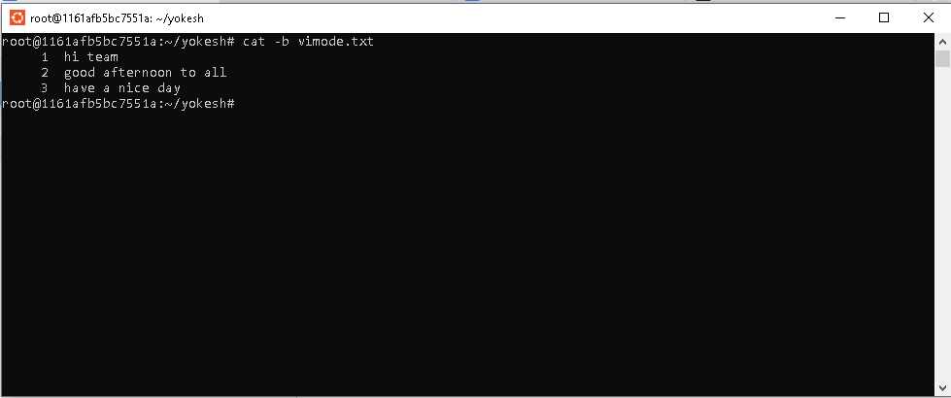

Task wc of 1 or more file:

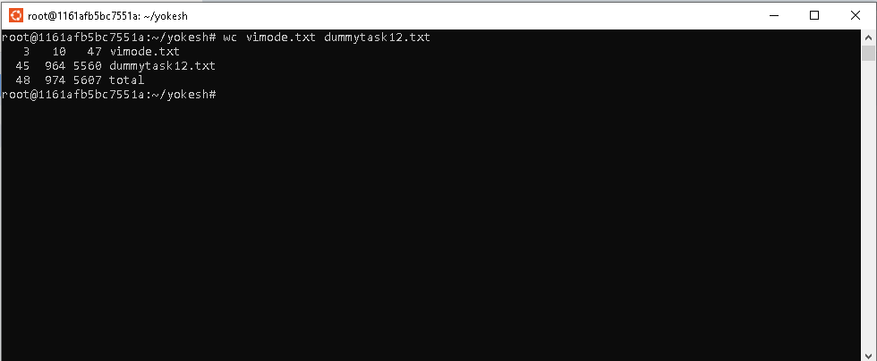

Task copy content from 1 file to another file:

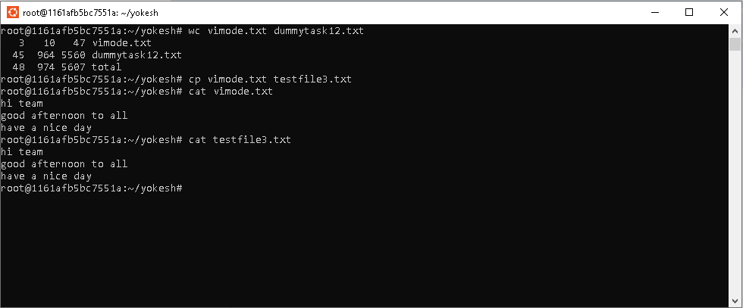

Task rename the file:

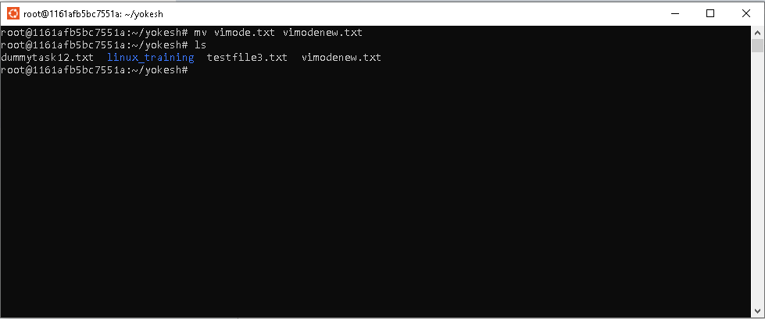

Task 34:

Can i remove or delete multiple files in linux..? How?

yes .

Rm filename

Eg : rm testfile1.txt

Rm * with file extension

Eg : rm *.txt

Task 35 / slash use:

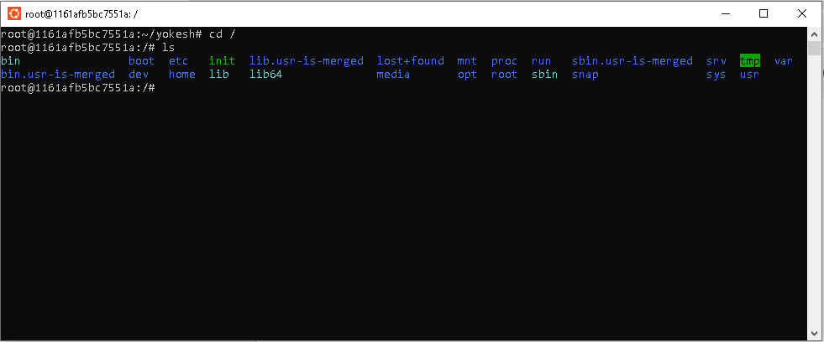

Task 36 ~ use:

Move to home directory

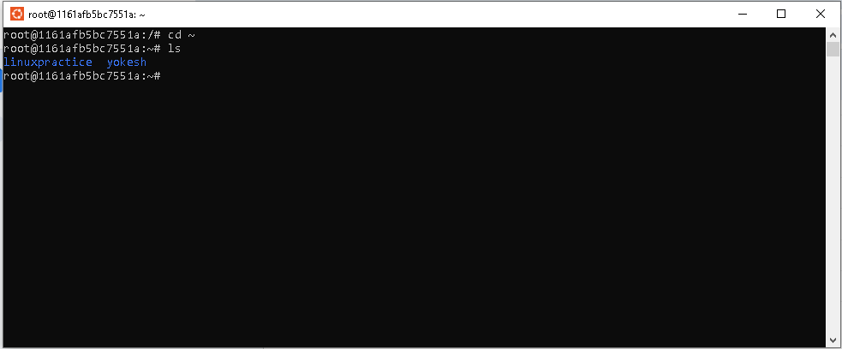

Task 37:

I have only one user in my vm so unable to switch user

Cmd : su - username

